User Manual

Restaurant Finder

Enrique Cordero

Sergiu Ghita

Hampus Gunnrup

Kevin Nie

Table of Contents

Welcome 3

Signing in as a guest 3

Query for a restaurant 3

Registering as a user 5

Registration Window 5

Login in 6

Login Window 6

Viewing a restaurant 7

User Profile 9

User Profile Window 10

Change User Password 11

Owner Profile 12

Owner Profile Window 13

Change Owner Password 14

Edit Restaurant 15

Administrator Functionalities 17

Edit Users 18

Edit Owners 19

Informational Messages: 20

# Welcome

Hi and welcome to our application to find the best restaurants of your choice in the Gothenburg Area. Please Read the user manual carefully to understand the full functionality of our program.

# Signing in as a guest

Whenever you open the program the first thing you should know is that you are automatically signed is as a guest. But don’t worry most of the main functionality of the program is available for all guests.

# Query for a restaurant

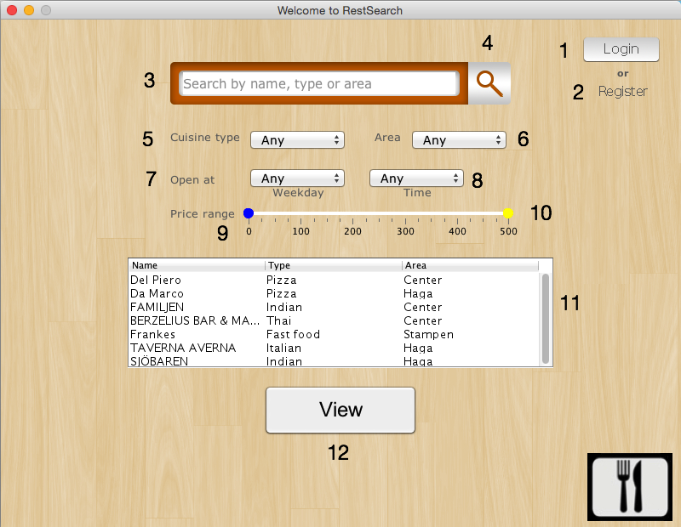

Image 1

Items Key (Refer to image 1):

1. Login Button: Takes you to the login window.
2. Register Button: Takes you to the register window.
3. Search Bar: This text field allows you to filter your restaurants by matching words or matching letters. This will filter any restaurant name, type or area that matches the word or the letters in the search bar. To perform the query you need to either press enter while having the focus on the search bar or by pressing the search button.
4. Search Button: Activates the filtering process with the information on the search bar.
5. Cuisine Type: This drop down option will allow you to filter the restaurants through a specific type of food. Just press on the arrow to view your cuisine type options.
6. Area: This drop down option will allow you to filter the restaurants through a specific area in Gothenburg. Just press on the arrow to view your area options.
7. Open at Weekday: This drop down option will allow you to filter the restaurants through whether or now they are open on a specific weekday. Just press on the arrow to choose the day of the week.
8. Open at Time: This drop down option will allow you to filter the restaurants through whether or not they are open on a specific time. Just press on the arrow to view the options of time. It is important to mention here that closing times of a restaurant is considered as the restaurant being closed. Ex. Restaurant has a closing time of 10pm and the filter is set to 10pm.
9. Price Range Min: This range slider will allow you to select the minimum price you would like to look for in a restaurant. Just slide the bar right or left to the desired amount.
10. Price Range Max: This range slider will allow you to select the maximum price you would like to look for in a restaurant. Just slide the bar right or left to the desired amount.
11. Restaurant Table: This table shows all the restaurants that match with your query. It will show the name, type and area of the restaurants that match or it will show No Restaurant Matches if no restaurants match your query. The table allows you to pick a restaurant to view.
12. View Button: This button will take you to the window that allows you to view the restaurant’s full details. Important to mention that you need to select a restaurant to be able to view its details. You do this by clicking on the Restaurant Table just on the row that represents the restaurant you would like to view.

# Registering as a user

Because the application focuses on something as subjective as restaurants, we also give you the opportunity to register as a user to be able to make comments and to grade a specific restaurant. This way if you want to go back to a restaurant you just need to take a look at your comments to remember how good or bad your experience there was.

But that’s not all. Are you a restaurant owner who would like to be a part of our system? You can also register as a restaurant owner and start adding restaurants.

All you need to do is click on the register button in the query window (refer to image 1).

## Registration Window

Here you can register as a user or you can register as a restaurant owner.

Items Key (Refer to image 2)

1. Username: This text field allows you to fill in whichever username you want to use. Important to mention here that there can only be one user with a specific username. So try to be clever and choose something no one else has chosen.
2. Password: This text field allows you to fill in whichever password you want to use.
3. Repeat Password: As a safety measure we would like to make sure that you have chosen the password you thought you did. By repeating the password you want we can make sure that’s the case.
4. Restaurant Owner Option: This option is for registering as a restaurant option. If the option is not clicked then it will register a regular user.
5. Cancel Button: This option will take you back to the query view without doing the registration.
6. Register Button: This option, if successful, will register you on the database as a user or an owner and will automatically log you in. This action will also take you back to the query view. If not successful it will tell you what the problem is and allow you to try again.

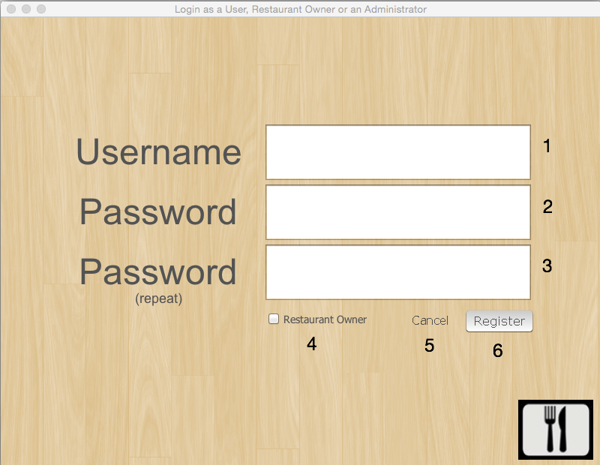

Image 2

# Login in

Are you already a registered user with us? Just go ahead and log in. All you need to do is to click on the login button in the query window (refer to image 1).

## Login Window

Here you can register whether you are a user, a restaurant owner or an administrator.

Items Key (refer to image 3)

1. Username: This text field is for you to fill in your username details.
2. Password: This text field is for you to fill in your password. You can press the enter key once you are done or simply click the login button.
3. Login Button: This button is to finalize the login procedure once you have filled in your username and your password. If successful it will log you into the program and will return you to the query window.
4. Cancel Button: This button will cancel the current operation and return you to the query window.

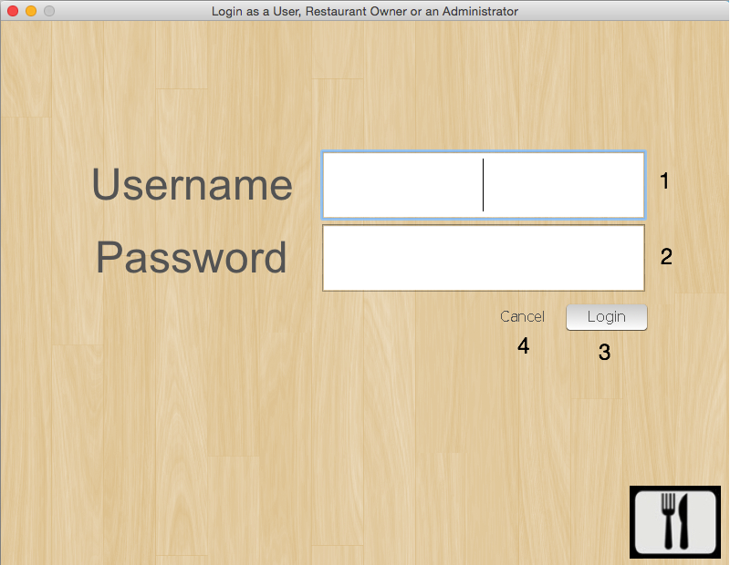

Image 3

# Viewing a restaurant

Now you are curious about a specific restaurant. Here you can view all the restaurant details. If you are logged as a user you will have option to add a comment and a grade (if no comment has been made on this restaurant) or in case you already added a comment you will be able to edit your comment or delete it. Buttons or text fields not at your disposal will be grayed out.

Items Key (refer to image 4):

1. Add a comment: This text box gives you the opportunity to add a comment. When you are done just click on the send button (item 7). Don’t forget to change your grade (item 6) before you send your comment in.
2. Reviews Table: Here you will find all the reviews made on this restaurant. You will be able to see the user who made the comment, the grade he gave the restaurant and the date of the comment. To view the details of the comment just click on a specific row and it will show on the comment text field (item 3).
3. Comment text field: Here a specific comment selected from the reviews table (item 2) will be displayed. If the comment was made by yourself you can choose to edit it or delete it. To edit it just start typing and then click the update review button (item 5). To delete it just click on the delete review button (item 4).
4. Delete Review: This button will allow you to delete a selected review written by yourself. Just select a specific review from the reviews table (item 2) and click on the delete button.
5. Update Review: This button will allow you to update your review. You can edit the comment on the comment text field (item 3) or you can edit the grade on the grade drop down (item 6). When you are done just click on the update review button.
6. Grade: This drop down will allow you to select a specific grade to give to the restaurant. If the drop down is grayed out you are not currently able to use it.
7. Send button: This button will allow you to post your review in the database. Once you click this button everyone will be allowed to see your opinion of the restaurant.
8. Back button: This button will allow you to go back to the query window.
9. Restaurant Details: This panel shows all the information regarding the restaurant. Important to mention that the description is a pop out that will become larger when you hover with your mouse over it.
10. Restaurant Picture: This is a picture of the restaurant chosen by the owner.

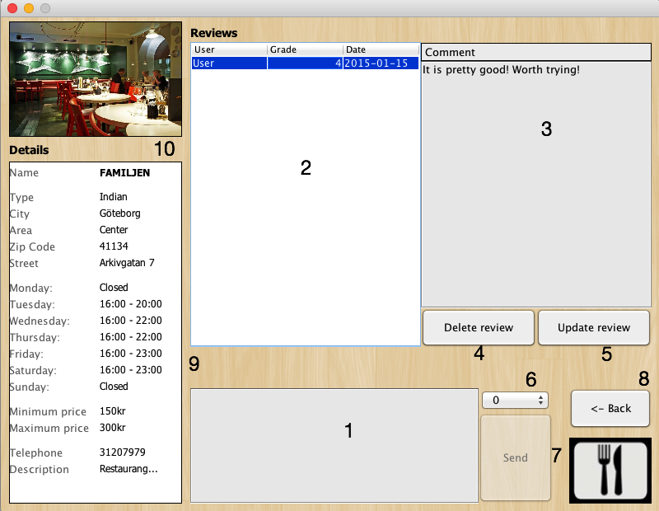

Image 4

# User Profile

As a registered user you are also allowed to have a profile. You access this window through the query window.

Item Key (refer to image 5)

1. My Profile Button: This button will allow you to access your Profile window.
2. Logout Button: This button will allow you to log out from the session.

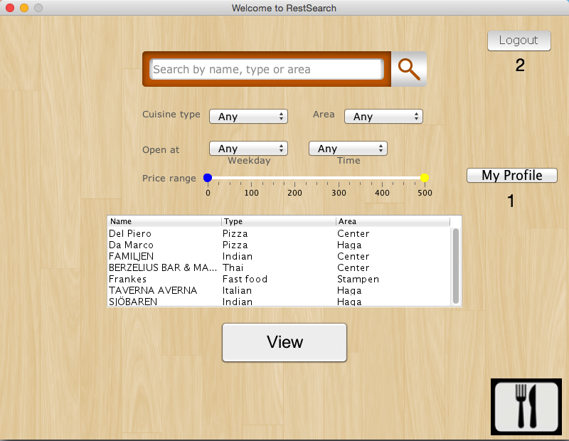

Image 5

## User Profile Window

Here you can add some information about yourself or you can choose to change your password. Here you will also find all your reviews and have the opportunity to delete them if you desire.

Items Key (refer to image 6)

1. Surname: Here you can add your name.
2. Family Name: Here you can add your family name.
3. Email: Here you can add your email.
4. Phone number: Here you can add your phone number. Please note only numbers are accepted so no special characters (-, /).
5. Area: Here you can choose the area of Gothenburg you live in.
6. Here you can write your city.
7. Update Info Button: This button will update your information. Please not that none of the details are required so feel free to choose which ones you would like to fill in.
8. Review Table: This table shows all of your reviews.
9. Delete Button: This button will allow you to delete a review. Just choose a specific review form the review table (item 8) and press the button delete.
10. Username: This label shows the username of the person currently logged in.
11. Edit password: This button will bring up a new view of this window that will allow you to edit your password.
12. Back: This button will take you back to the query window.

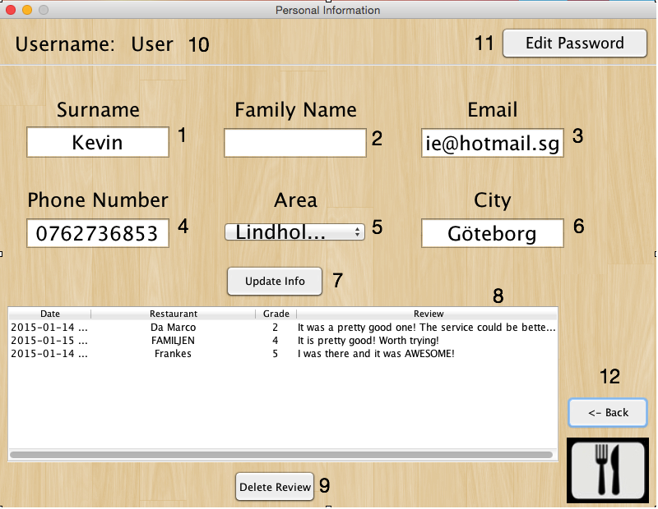

Image 6

## Change User Password

As part of the user profile window you are allowed to change your password.

Items Key (refer to image 7)

1. Current password: Here you must fill in your current password.
2. New password: Here you fill in your new desired password.
3. Repeat new password: Here you must repeat the password exactly as the one you filled in the new password option.
4. Save Button: This button will allow you to save the changes to your password. If successful it will bring you back to the regular view. If not successful it will let you know which mistakes you have.
5. Cancel Edit: This button will cancel the editing of your password and will bring you back to the regular view of your profile.
6. Back: This button will take you back to the query window.
7. Username: This label shows the username of the person currently logged in.

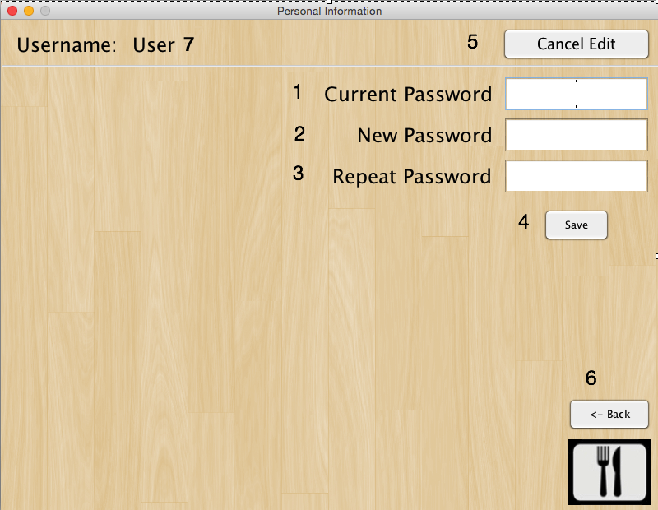

Image 7

# Owner Profile

As a registered owner you are also allowed to have a profile. You acces your profile through the query window.

Items Key (refer to image 8)

1. Logout Button: This button allows you to logout from the session.
2. My profile Button: This button allows you to access your profile window.
3. Restaurants Button: This button allows you to access your restaurants.

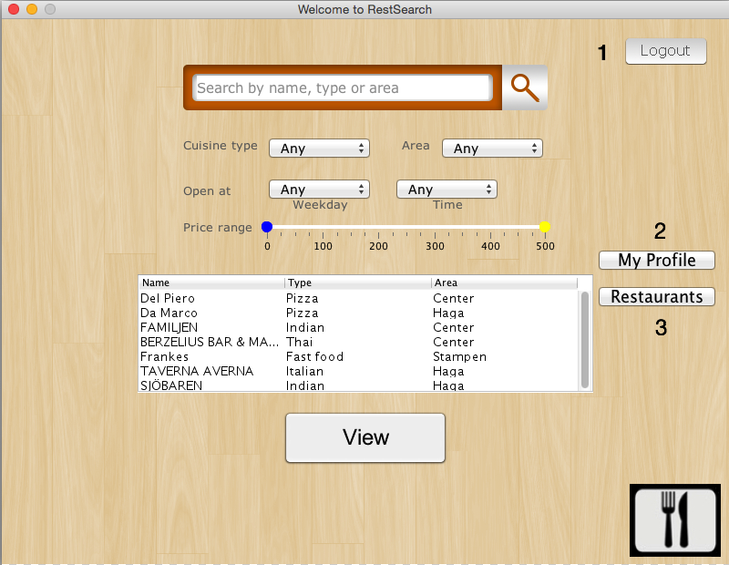

Image 8

## Owner Profile Window

Here you can add some information about yourself or you can choose to change your password.

Items Key (refer to image 9):

1. Surname: Here you can add your name.
2. Phone number: Here you can add your phone number. Please note only numbers are accepted so no special characters (-, /).
3. Family Name: Here you can add your family name.
4. Email: Here you can add your email.
5. Update Info Button: This button will update your information. Please not that none of the details are required so feel free to choose which ones you would like to fill in.
6. Edit password: This button will bring up a new view of this window that will allow you to edit your password.
7. Username: This label shows the username of the person currently logged in.
8. Back: This button will take you back to the query window.

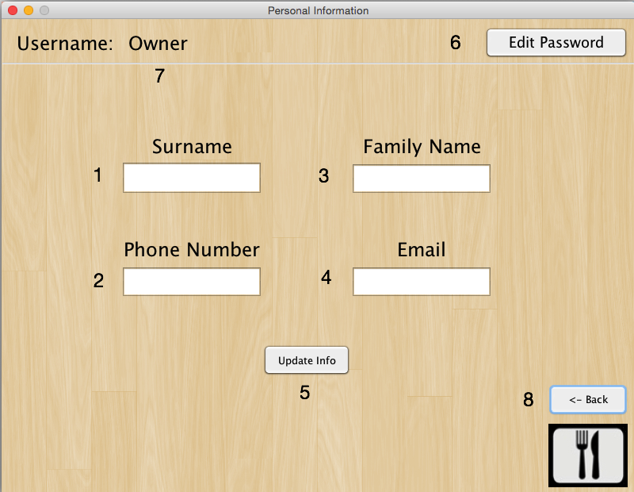

Image 9

## Change Owner Password

As part of the owner profile window you are allowed to change your password.

Items Key (refer to image 10)

1. Current password: Here you must fill in your current password.
2. New password: Here you fill in your new desired password.
3. Repeat new password: Here you must repeat the password exactly as the one you filled in the new password option.
4. Save Button: This button will allow you to save the changes to your password. If successful it will bring you back to the regular view. If not successful it will let you know which mistakes you have.
5. Cancel Edit: This button will cancel the editing of your password and will bring you back to the regular view of your profile.
6. Username: This label shows the username of the person currently logged in.
7. Back: This button will take you back to the query window.

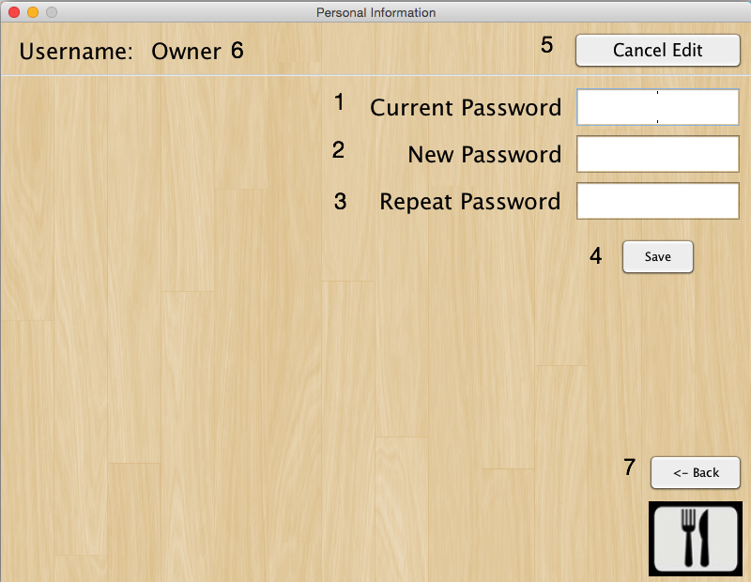

Image 10

## Edit Restaurant

An owner can also edit his own restaurants. To access this window he needs to click on the restaurants button in the query view (refer to image 8).

Items key (refer to image 11):

1. Create new Button: This button allows you to create a new restaurant. All the appropriate fields will be available for edition. When you are done just click on the add button. If you don’t want to save the restaurant just click on the discard button (images not available).
2. Update Changes Button: This button allows you to update any changes done to an existing restaurant.
3. Delete Button: This button allows you to delete a selected restaurant.
4. Search Restaurants: This text field allows you to filter through your own restaurants and displays in the Restaurant List (item 5) the restaurants that match the words typed in.
5. Restaurants List: Shows all the available restaurants corresponding to the owner. Can also be filtered through the search restaurants bar (item 4).
6. Restaurant Information: This area shows all the required information for a restaurant to have. Important to mention that Image URL needs to point to an available image.
7. Restaurant Schedule: This area shows the restaurant schedule. Note that the format is HH:MM.
8. Closed Option: This option is can be clicked if the restaurant is closed that specific day. Note that if clicked the opening and closing times of the restaurant will be grayed out and not available for modification.
9. 24/7 Option: This option is for restaurants that will work 24hrs that day. Note that if clicked the opening and closing times of the restaurant will be grayed out and not available for modification.
10. Back Button: This button will bring you back to the query window.

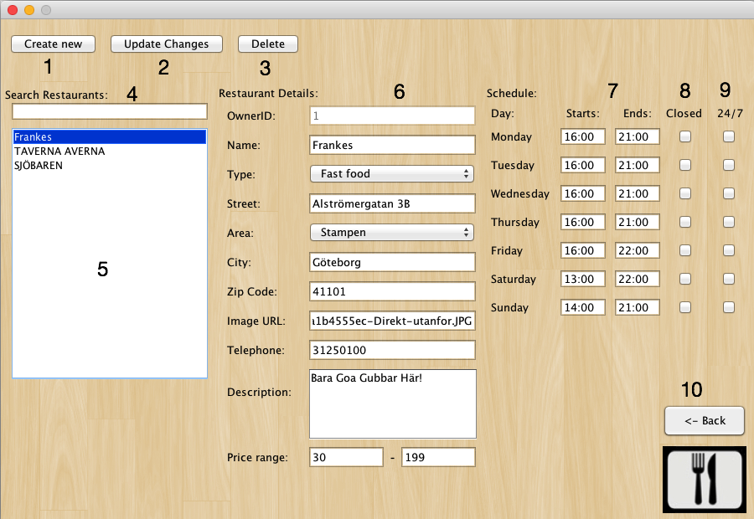

Image 11

# Administrator Functionalities

As an administrator you can do the basic functionality of the program. You could query restaurants and view its details. You can also edit restaurants, delete users, delete their reviews or delete owners. All this options are accessible to the administrator through the query window.

Important Note: Edit restaurants capabilities of the administrator is almost the same as the edit restaurant for the owner and therefore will be understood that for reference to how to edit a restaurant the administrator should refer to the Edit Restaurant part of this manual.

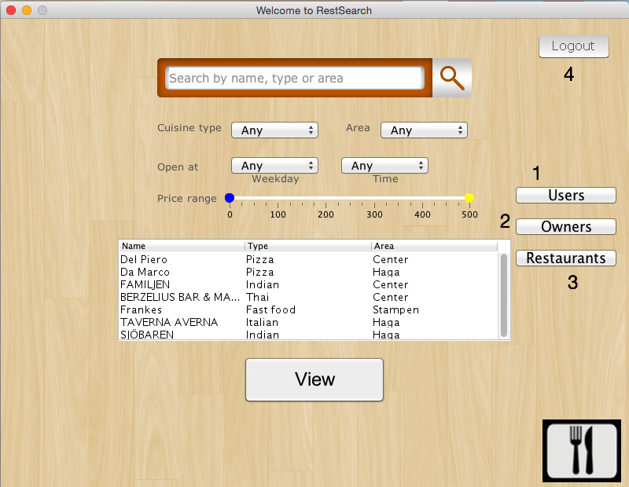

Image 12

Items Key (refer to image 12):

1. Users Button: This button will allow an administrator to access the Edit Users window.
2. Owners Button: This button will allow an administrator to access the Edit Owners window.
3. Restaurants Button: This button will allow an administrator to access the Edit Restaurants window (refer to image 11).
4. Logout Button: This button will log out the administrator from the session.

## Edit Users

Administrators can delete users in case the user is inactive for too long, the user wants his account cancelled or the user has been abusive with the usage of the program. Because a user has a set of reviews attached to him then the administrator can also delete any of those specific reviews for the same reasons mentioned above.

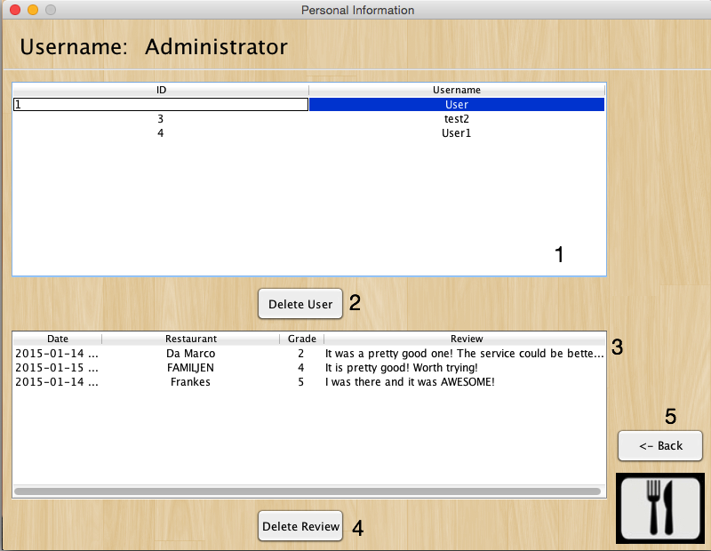

Image 13

Items Key (refer to image 13):

1. Users Table: This table contains all the users in the database.
2. Delete User Button: This button deletes a specific user selected form the users table (item 1).
3. Reviews Table: This table will only contain information if the administrator has selected a specific user (because reviews are attached to a specific user) from the users table (item 1). The table will contain all the reviews from the specific user.
4. Delete Review Button: This button will delete a specific review selected from the reviews table (item 3).
5. Back Button: This button will take you back to the query window.

## Edit Owners

Administrators can delete owners in case the owner is inactive for too long, the owner wants his account cancelled or the owner has been abusive with the usage of the program.

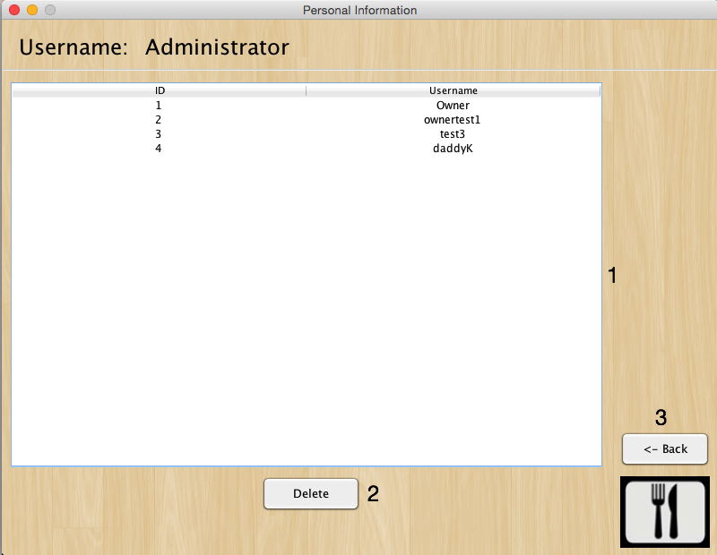

Image 14

Items Key (refer to image 14):

1. Owners Table: This table will contain all the owners in the database.
2. Delete Button: This button will delete a specific owner previously selected from the owners table (item 1).
3. Back Button: This button will return you to the query window.

# Informational Messages:

Because informational messages are so self explanatory they will not be explained in detail. The basic messages the program has are the following:

* Error Messages: They will inform you of a program error or a human error. It will display the word Error as a title.
* Success Messages: They will inform you that the transaction requested was successful. It will display the word success as a title.
* Question Messages: They will query the user on whether or not they are sure of their decision. This messages will have a yes / no option for the user to choose from.